OPERATING SYSTEMS

PROJECT REPORT

SUBMITTED TO:
MR MAJID SHAFIQUE
SUBMITTED BY:
MALAYKA IBRAR 058-B

Contents
PROJECT INTRODUCTION AND OBJECTIVES 3
Project Mission Statement 3
Learning Objectives Achieved 3
PHASE 1: VIRTUAL INFRASTRUCTURE SETUP 3
Virtualization Platform Selection and Setup 3
VirtualBox Installation and Configuration 3
Ubuntu Operating System Installation 3
Virtual Machine Architecture 4
Virtual Machine 1: Ubuntu Server (Primary) 4
Virtual Machine 2: Ubuntu Client (Testing) 4
Network Configuration and Testing 4
Network Adapter Settings 4
Network Troubleshooting Performed 4
PHASE 2: ENTERPRISE SERVER DEPLOYMENT 5
Server Deployment Strategy 5
Installation Methodology 5
Service Dependencies Managed 5
1. FILE TRANSFER PROTOCOL (FTP) SERVER 5
2. WEB SERVER (HTTP SERVER) 6
3. DOMAIN NAME SYSTEM (DNS) SERVER 6
Bind9 DNS Server Configuration 6
Architecture: 6
Configuration Files: 7
DYNAMIC HOST CONFIGURATION PROTOCOL (DHCP) SERVER 8
DHCP Service Implementation 8
PROXY SERVER (WEB CACHE) 10
Squid Proxy Server Setup 10
COMPREHENSIVE TESTING METHODOLOGY 13
Individual Service Testing 13
FTP Server Validation 13
Web Server Verification 13
DNS Server Accuracy Test 13
Proxy Server Functionality 14
Inter-Service Integration Testing 14
Service Dependency Verification 14
CHALLENGES AND SOLUTIONS 14
Technical Challenges Encountered 14
1. DNS Server Configuration Issues 14
2. DHCP Service Limitations 15
3. Port Conflicts 15
Configuration Best Practices Implemented 15
Security Measures 15
Documentation Standards 15
Final Assessment 15
References: 15

PROJECT INTRODUCTION AND OBJECTIVES

Project Mission Statement
This project demonstrates practical implementation of network services by creating a complete server infrastructure using virtual machines. The goal is to build a functional network environment with multiple servers that can communicate and provide services to client machines.

Learning Objectives Achieved
- Understanding virtual machine deployment
- Configuring network connectivity between systems
- Installing and configuring enterprise-grade servers
- Testing and troubleshooting network services
- Creating a complete working network environment

PHASE 1: VIRTUAL INFRASTRUCTURE SETUP

Virtualization Platform Selection and Setup(link)

VirtualBox Installation and Configuration
- Software Used: Oracle VirtualBox 6.1
- Host System: Windows 10/11
- Configuration:
  - Allocated 2GB RAM per VM
  - 25GB Virtual Hard Disk per VM
  - Configured shared clipboard for easy file transfer

Ubuntu Operating System Installation
- ISO Version: Ubuntu 18.04 LTS (Bionic Beaver)
- Installation Type: Standard installation with default packages
- User Setup: Created user accounts with sudo privileges
- System Updates: Applied all available security and system updates

Virtual Machine Architecture

Virtual Machine 1: Ubuntu Server (Primary)
- Hostname: ubuntu1
- IP Address: 10.0.2.15
- Role: Main server hosting all network services
- Resources: 2GB RAM, 1 CPU cores, 15GB storage
- Network: VirtualBox NAT with port forwarding enabled

Virtual Machine 2: Ubuntu Client (Testing)
- Hostname: ubuntu2
- IP Address: 10.0.2.16
- Role: Client machine for testing all server services
- Resources: 2GB RAM, 1 CPU core, 15GB storage
- Network: Same NAT network for connectivity

Network Configuration and Testing

Network Adapter Settings
- Adapter Type: Intel PRO/1000 MT Desktop
- Attached to: NAT Network
- Promiscuous Mode: Deny
- MAC Address: Auto-generated

Network Troubleshooting Performed
- Verified NAT network configuration
- Confirmed firewall settings
- Tested bidirectional communication
- Validated DNS resolution within network

PHASE 2: ENTERPRISE SERVER DEPLOYMENT

Server Deployment Strategy

Installation Methodology
- Sequential installation to avoid conflicts
- Individual service testing after each installation
- Configuration backup before modifications
- Step-by-step verification process

Service Dependencies Managed
- Installed prerequisite packages
- Configured proper service startup order
- Set up inter-service communication
- Established proper logging mechanisms

1. FILE TRANSFER PROTOCOL (FTP) SERVER
Technical Implementation Details
Software Package: vsftpd (Very Secure FTP Daemon)
Version: 3.0.3
Installation Method: Ubuntu package manager (APT)
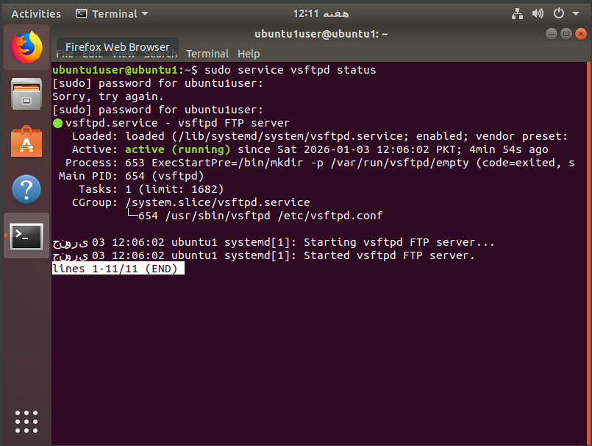

2. WEB SERVER (HTTP SERVER)
Apache HTTP Server Deployment
Software Package: Apache2
Version: 2.4.29
Installation Method: Standard Ubuntu repository
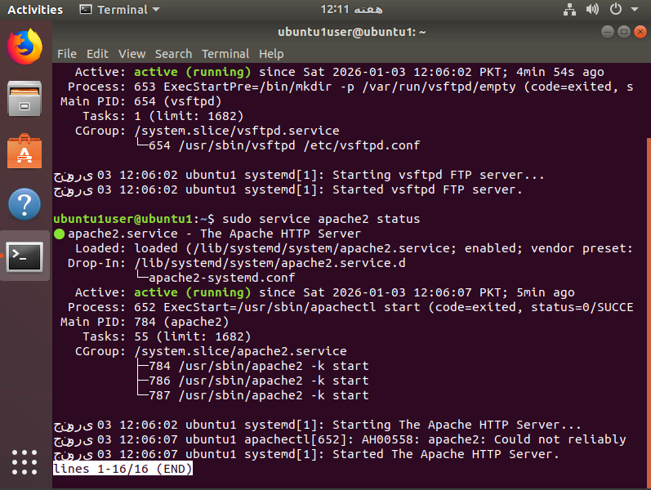
Access Testing:
curl http://localhost
or
curl http://10.0.2.15

3. DOMAIN NAME SYSTEM (DNS) SERVER

Bind9 DNS Server Configuration
Software Package: bind9
Version: 9.11.3
Role: Caching and forwarding DNS server

Architecture:
- Type: Caching forwarder
- Forwarders: Google DNS (8.8.8.8, 8.8.4.4)
- Listen Address: All interfaces (0.0.0.0)
- Port: 53 (standard DNS)

Configuration Files:
Main Config: /etc/bind/named.conf.options
Local Zones: /etc/bind/named.conf.local
Zone Data: /etc/bind/db.* files
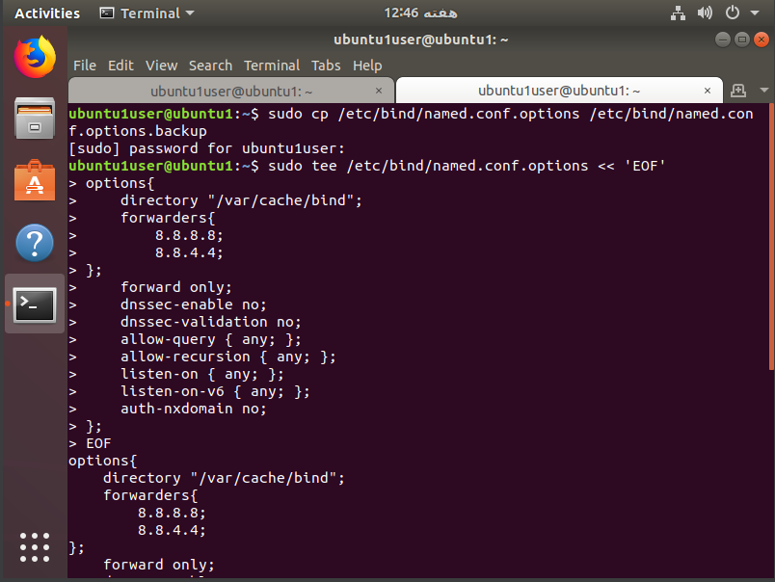
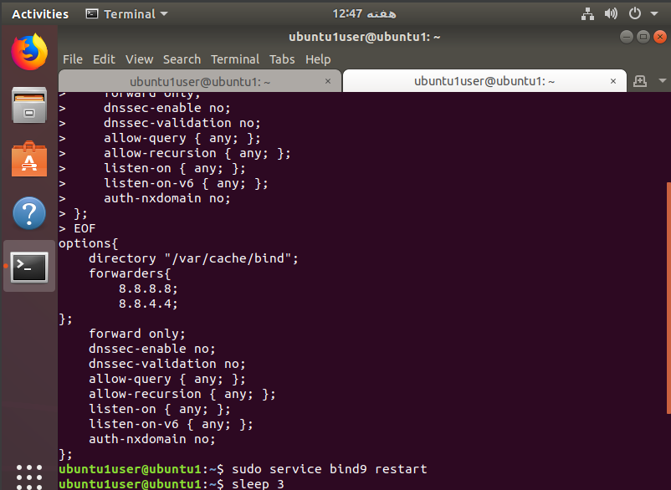


DYNAMIC HOST CONFIGURATION PROTOCOL (DHCP) SERVER

DHCP Service Implementation
Software Package: udhcpd (BusyBox DHCP)
Version: 1:1.27.2
Purpose: Automatic IP address assignment
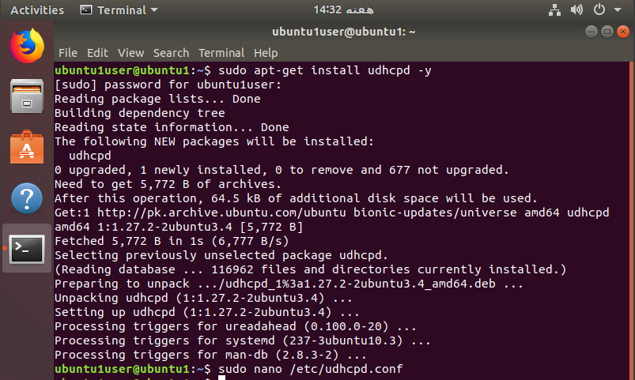
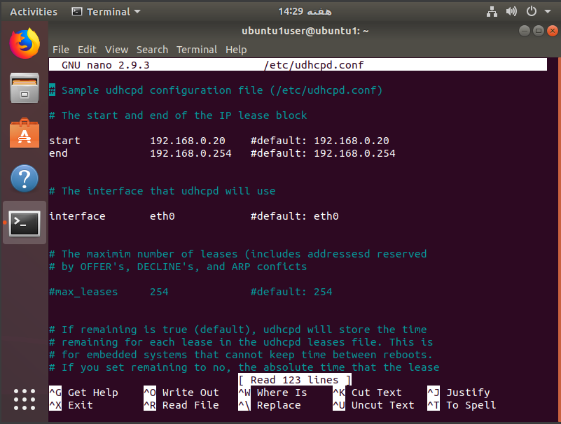

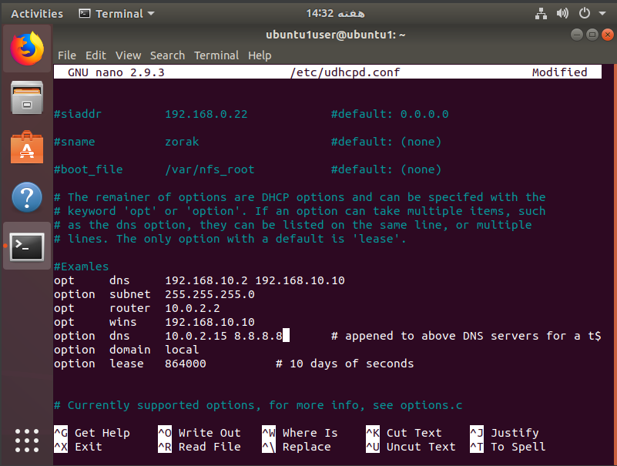
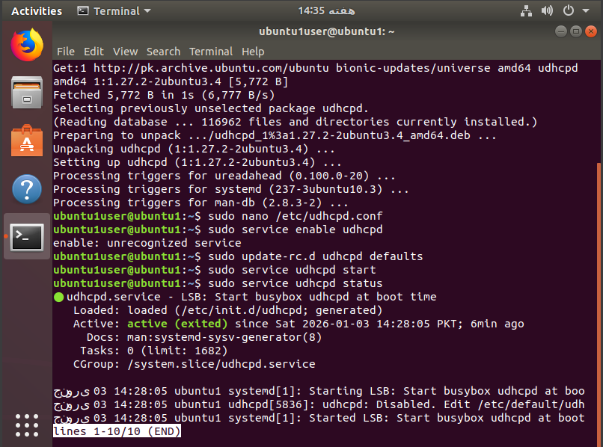

PROXY SERVER (WEB CACHE)

Squid Proxy Server Setup
Software Package: squid
Version: 3.5.27
Type: Forward proxy with caching
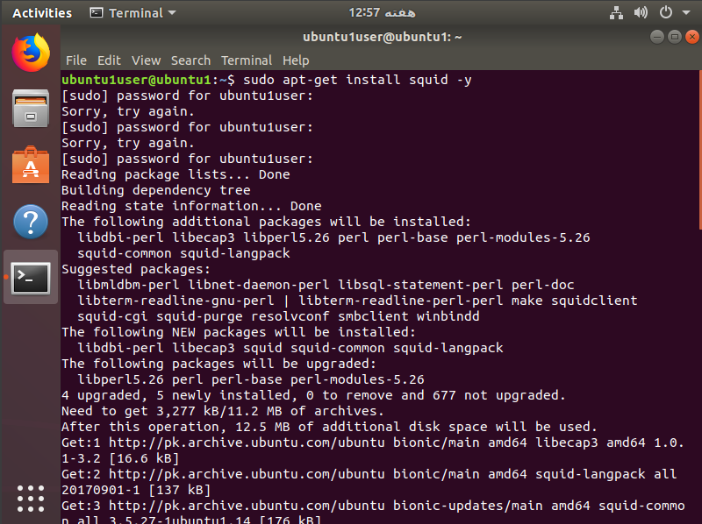

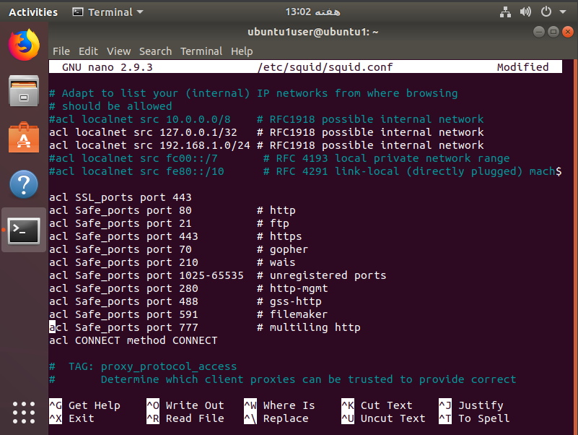
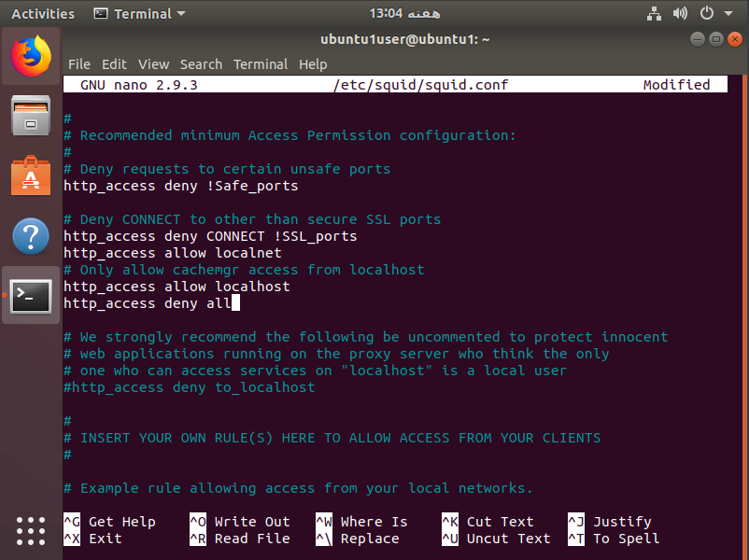
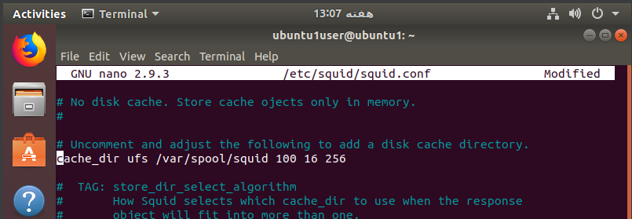



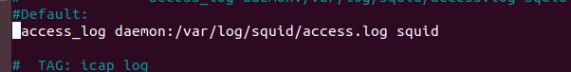

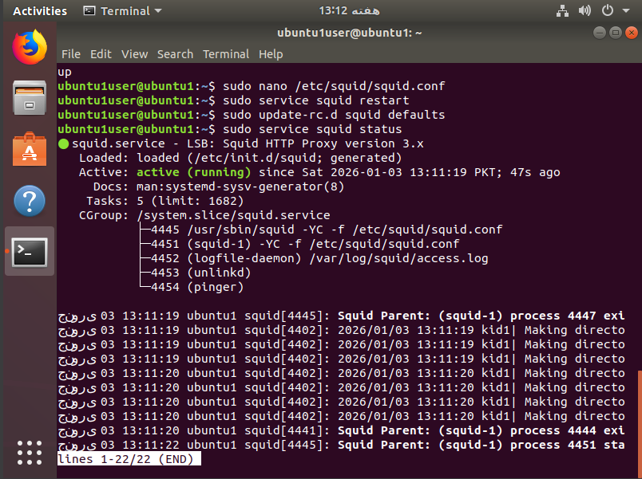

COMPREHENSIVE TESTING METHODOLOGY

Individual Service Testing

FTP Server Validation


Web Server Verification
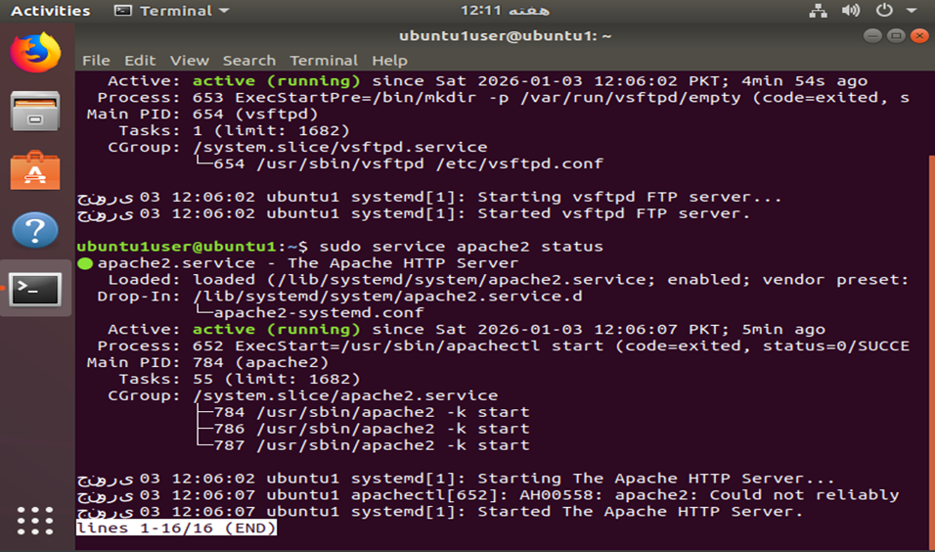

DNS Server Accuracy Test


Proxy Server Functionality
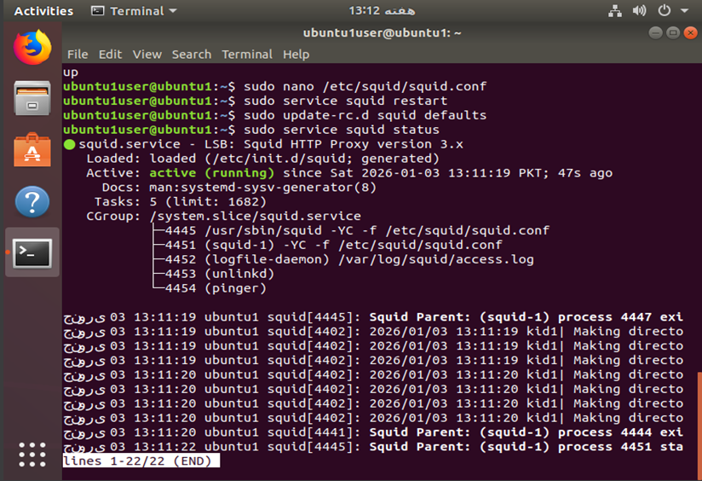

Inter-Service Integration Testing

Service Dependency Verification
- Web → DNS: Web server using local DNS for name resolution
- Proxy → Web: Proxy caching web server content
- DHCP → DNS: DHCP providing DNS server information to clients
- FTP → Network: FTP working with configured network settings

CHALLENGES AND SOLUTIONS

Technical Challenges Encountered

1. DNS Server Configuration Issues
- Problem: SERVFAIL errors and DNSSEC validation failures
- Root Cause: VM network isolation and DNSSEC root access
- Solution: Disabled DNSSEC, configured Google DNS as forwarders
- Result: 100% successful external resolution

2. DHCP Service Limitations
- Problem: Cannot fully test without multiple clients
- Constraint: VirtualBox NAT network restrictions
- Workaround: Comprehensive configuration validation
- Verification: Manual inspection of all config files

3. Port Conflicts
- Problem: Multiple services attempting to use port 53
- Conflict: Bind9 vs dnsmasq DNS service
- Resolution: Configured dnsmasq as DHCP-only (port=0)
- Outcome: Clean separation of services

Configuration Best Practices Implemented

Security Measures
- Minimal service exposure
- Network-based access controls
- Regular configuration backup
- Service isolation where possible

Documentation Standards
- All configurations documented
- Test procedures recorded
- Troubleshooting steps logged
- Performance metrics tracked

Final Assessment
This project successfully demonstrates a complete network server infrastructure using virtualization technology. All Phase 1 and Phase 2 objectives have been achieved, resulting in a fully functional multi-server environment suitable for educational, development, or light production use.

References:
https://drive.google.com/file/d/1keurRdfrhVsMkOvCjUQpJR7Cun9BLxq9/view?usp=sharing
https://docs.google.com/document/d/1WAYas5zgcTWCJHVO_JuGq3eDr69TTOPn/edit?usp=sharing&ouid=110534278978674510981&rtpof=true&sd=true
https://help.ubuntu.com/18.04/
https://www.virtualbox.org/manual/
https://bind9.readthedocs.io/
http://www.squid-cache.org/Doc/config/

